Solar Generation for Remote Boreholes >
Team 12: Team Power >

Authors
Xiaobin Lin (21566849)

Project Design Approach

Project Partners: Mr. John-Ross Torre, Jacobs Engineering Group Inc.

Demonstrator: < Catherine Hatch >

Academic Supervisor:
< Sally Male>

Word Count: 2314

Word Limit: 2500

Version <1.2>
Revision History
Date | Version |  | Description | Author
31/03/17 | 1.0 |  | Format and insert group drafts into temple, begin editing | Xiaobin LIN
01/04/17 | 1.1 |  | Continue editing, create additional content to improve flow | Xiaobin LIN
05/04/17 | 1.2 | Add cover sheets and Final Edit |  | Xiaobin LIN

Table of Contents
1. Introduction 4
1.1 Project Goals 4
1.2 Purpose 4
1.3 Scope 4
1.4 Structure of submission 4
1.5 References 4
2. Individual responsibility and contribution 5
3. Design Methodology --- Solar-Wind-Battery 6
3.1 Solar 6
3.2 Wind 7
3.3 Battery Storage 8
4. Simulation Tool --- HOMER 9
5. Analysis --- Reliability of Power Supply 9
6. Conclusion 10
7. Appendices 10
7.1 Appendix A: Solar Generation for Remote Boreholes 11
7.2 Appendix B: Climatic Information at Newman, WA 12
7.3 Appendix D: Requirements Priority Table including Classifications. EXP - Expecters, SPO - Spoken, UNS - Unspoken, EXC - Exciters 13

Solar Generation for Remote Boreholes
Design Approach

Introduction

Project Goals
The main goal of this project is to design a power system to supply 90KW to three bore pumps situated 10 km from the mine site. The requirement of this power system must operate and supply constant power 24/7. And a cost-effective method needs to be derived to satisfy the requirement of this project.

Purpose
This document aims to design a fully renewable energy system (RES) with the storage to supply power to remote boreholes in WA. Team12 provides options for this project, which includes base case (On-grid), hybrid solutions, and fully renewable energy. Using fully RES is one of the design options. Analyzing this system is necessary for Team 12 to compare with other options and determine the optimal choice.

Scope
This report represents a RES design option of “Solar Generation for Remote Boreholes” project created by Jacobs Engineering Group Inc. The design option deals with the design phase of this project, choosing the optimal design approach to achieve the client’s objectives. This report concerns that a system consists of wind and solar energy pairing with the reliable battery storage and a simulation introduction by the Homer tool.

Structure of submission
Design Methodology:
- Solar
- Wind
- Battery
- Via Homer Simulation & Analysis

References
[1] "Advantages of Solar Power or Photovoltaic Panels for Energy Usage", Soluxesavings.com, 2017. Available:
http://www.soluxesavings.com/advantages-solar-power-over-alternate-energy-sources-a-122.html

[2] A. Us and M. Maehlum, "Which Solar Panel Type is best? Mono-, Polycrystalline or Thin Film?" Energy Informative, 2017. Available:
http://energyinformative.org/best-solar-panel-monocrystalline-polycrystalline-thin-film

[3] A. Us and M. Maehlum, "Which Solar Panel Type is best? Mono-, Polycrystalline or Thin Film?" Energy Informative, 2017. Available:
http://energyinformative.org/best-solar-panel-monocrystalline-polycrystalline-thin-film

[4]"Australian Climate Averages - Sunshine Hours", Bom.gov.au, 2017. Available: http://www.bom.gov.au/jsp/ncc/climate_averages/sunshine-hours/index.jsp

[5] "Advantages and Challenges of Wind Energy | Department of Energy", Energy.gov, 2017. Available: http://energy.gov/eere/wind/advantages-and-challenges-wind-energy

[6] A. Pirolini, "Collecting and Storing Energy from Wind Turbines", AZo Cleantech.com, 2017. Available: http://www.azocleantech.com/article.aspx?ArticleID=488

[7] "Batteries, Rechargeable - Advantages and Disadvantages", Staff.drewloker.com, 2017. Available: http://staff.drewloker.com/battery.htm

[8]J. Edie, S. Al-Hallaj and G. Albright, 2017. Available:
http://www.batterypoweronline.com/main/wp-content/uploads/2012/07/Lead-acid-white-paper.pdf

[9] "Case study: Simulation and optimization of photovoltaic-wind-battery hybrid energy system in Taleghan-Iran using homer software", AIP Scitation, 2017. Available: http://scitation.aip.org/content/aip/journal/jrse/4/5/10.1063/1.4754440

[10] "HOMER - Hybrid Renewable Microgrid System Design Software", Homerenergy.com, 2017. Available:
http://www.homerenergy.com/HOMER-getting-started-guide.html

[11] A. Cano, F. Jurado, H. Sanchez, L. Fernández-Ramírez and M. Castañeda, 2017. Available: https://www.researchgate.net/publication/262880414_Optimal_sizing_of_standalone_hybrid_systems_based_on_PVWTFC_by_using_several_methodologies

Individual responsibility and contribution
- Xiaobin LIN, as a team member attends the regular meeting on Tuesday and Friday afternoon;
- As a minutes-takers in week 5and week 6 ;
- Will be a chairperson in week 7and week 8;
- Will be a representative to attend the partner meeting in week 11;
- Conduct the research of geographical position and climate in Newman;
- Analysis and write the project requirements of safety, economy, telemetry, and maintainable including description of requirement, requirement origin, justification for assigned priorities, and testability (which is 4,5,6,7 in Appendix D);
- Literature review of solar PV, LNG, and write literature review of data sheets of Grundfos MMS 6000 in RA;
- Do the design option: Solar-Wind-Battery.

Design Methodology --- Solar-Wind-Battery

Solar
Now, there is variety of renewable energy sources in daily life, with solar energy more economically competitive against other energy. Compared to traditional fossil fuels and other non-renewable source, solar energy can be zero carbon release, neglecting the production of solar panels. For tide and wave energy, because the generating equipment must be placed on or in the ocean, the marine ecosystem could be adversely impacted. Moreover, high O&M cost cannot be suitable for this project [1]. The sun's rays can be absorbed by solar photovoltaic (PV) panels as sources of energy to generate electricity [2]. The advantages and disadvantages of implementing a solar PV system are as follows:
Table 1: Advantages and Disadvantages of Solar [2]
Advantages | - Easy to install and disassemble;  - Long use life;  - No need to service specially;  - High reliability;  - Economically viable, no energy consumption;  - Mechanical wear resistance;  - High compatibility with other technologies.
Disadvantages | - Not suitable for regions of short solar exposure (regions of high latitude);  - Highly weather-dependent;  - Low efficiency;  - Occupy a large area.

Most solar PV panels now are based on variation of silicon, usually different kinds of silicon with variable purity. The panel that made by high purity silicon have high efficiency, which mean the solar energy can be converted to more electricity, while the silicon purifying process is expensive [3]. Specifically, silicon solar PV panels are usually made of either monocrystalline silicon or polycrystalline silicon [2]. Monocrystalline has a higher efficiency than polycrystalline; however, the cost of manufacturing is much higher [2]. The monocrystalline will usually have a longer expected life, which will offset some of those costs [2]. Battery storage is the most compatible with solar PV systems [2].
Climate information requirements of project site
Each technology has specific requirements to optimize functionality and suitability for the system, for example a solar PV system will work more effectively in areas that have higher solar radiation. The available background climate information can be found in the Figure 1, which is high number of sunshine hours at around Newman (More details refer to Appendix B [4]). Therefore, solar can be considered in this design option.

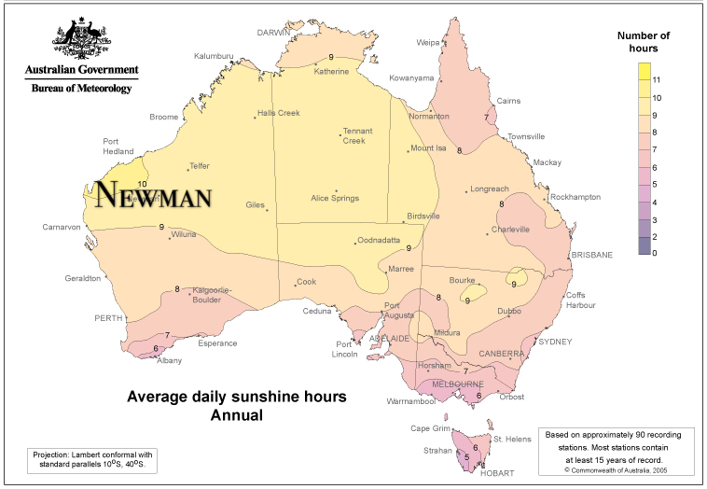
Figure 1: Average daily sunshine hours annual

Wind
Wind energy harvesting employs air flow movement in generating sources of electricity [5]. Currently, wind power is one of the cheapest renewable energy technologies [6]. In order to harness the kinetic energy supplied by an air flow, wind turbines can be implemented [5]. Figure 2 depicts the motion of air flow through an impeller-driven wind turbine design. When an air flow passes through the impeller rotor area, kinetic energy supplied by the air flow translates to a rotational energy experienced by the turbine impeller [5]. The impeller rotation, employing Faraday’s law of electrical induction, causes a connected generator to spin producing an electrical current [5]. 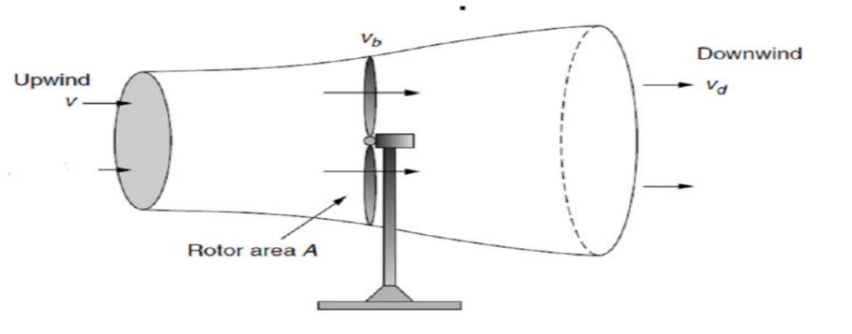
Figure 2: Wind behaviour around a wind turbine
Table 2: Advantages and Disadvantages of Wind [5]
Advantages | - A renewable, clean and sustainable energy source;  - Wind is an abundant energy source;  - Wind power is a relatively cheap source;  - Wind farms/turbines can be constructed on already established farm lands.
Disadvantages | - Wind power must be able to compete financially with conventional electrical generation methods;  - Optimal wind farm sites are generally remotely located;  - Wind farm and resource development may not be feasible on specified land;  - Wind turbines may cause noise pollution and aesthetic obstructions;  - Rotating turbine blades can potentially harm surrounding wildlife.
Depending on the different structure, the wind turbine can be classified to vertical axis wind turbine and horizontal axis wind turbine. Turbine selection is also dependent on local weather conditions and the power capacity demands of the client. The decision to use wind energy for this system was based on the abundance of the energy source. The average morning wind speed is 9.1km/h and afternoon is 9.4km/h [4]. Secondly, wind energy offers a clean and renewable method to energy production when modelling a power system to be independent of diesel electricity generation. Wind energy harvesting additionally offers a cheap energy source and creates job opportunities in areas where wind turbines are installed.

Battery Storage
The battery can be introduced as the energy storage in the system based on renewable sources due to their fluctuation and the insufficient reliability of supply. As a result of the uncertain nature of solar panel and wind turbine, battery can be considered to supply the load via storing energy during periods of high energy production brought on by high solar exposure or strong winds.
The main types of batteries for consideration are sealed lead acid or lithium ion [7]. The advantages and disadvantages of using battery storage are as follows:
Table 3: Advantages and Disadvantages of Battery [7]
Advantages | - Provide longer run time at a higher power rating.
Disadvantages | - Usually cannot be fully discharged;  - Large initial capital investment;  - Take time to recharge; and  - Require electricity source to recharge.

Best storage for solar PV is batteries [8], which can match the design of PV system model. However, when considering the trade-off analysis for a specific application of batteries, there are lots of factors need to consider. Especially for initial cost, lifetime, weight, volume, temperature sensitivity all plays a significant role in battery selection [8]. Based on its common market application, advantages and disadvantages of these two types of batteries are analysed and compared as shown in the following table [8].
Table 4: Lead Acid VS Lithium-ion
Cost ($/kWh) | VRLA lead acid (25℃) | Lithium-ion
Installed capacity | 100 kWh | 50 kWh
Battery cost | $12000 ($120/kWh) | $30000 ($600/kWh)
Installation cost | $20/kWh | $3.6/kWh
Lifetime cost | $0.34/kWh throughput | $0.40/kWh throughput
Transportation cost | $28/kWh | $5/kWh
Lifetime (hours) | 1000 @ 50% DoD1 | 1900 @ 80% DoD
1DoD = Depth of discharge.
Because VRLA lead-acid can be easily affected by the temperature, moreover, for a lead acid system to provide the same amount of energy, it must have a greater nameplate energy capacity than the lithium-ion battery [8]. In terms of cycle life comparison, lithium-ion has higher cycle life than lead acid in deep discharge applications [8]. Therefore, lithium-ion can provide better operation in a lot of situations, specifically in hot climates and that is why they are chosen in this design and future simulation process.

Simulation Tool --- HOMER
The National Renewable Energy Laboratory’s (NREL) hybrid optimization model for electric renewables HOMER simulation software will be considered to perform the optimal design and techno-economic viability of hybrid energy system at project site [9]. Firstly, in order to achieve the solar-wind-battery model, a specific location (longitude and latitude of project site) can be entered through the “Search Box”, thus it can download observed resources data incudes solar and wind radiation from data bases for this project site. Simulating with HOMER requires some input information regarding resources, economic constraints, and control methods. It also requires inputs of the discount rate, inflation rate, maximum annual capacity shortage, project lifetime, component types, their costs, efficiency, etc. Also, HOMER can present simulation results in a lot of tables and graphs that contribute to analysing system configuration. A system’s technical feasibility and the economic analysis can be estimated by HOMER simulation. Furthermore, Homer can rank the systems based on the total net present cost (NPC), which can be used to compare system design options and choose the cheapest NPC [10].
𝑁𝑃𝐶= 𝐶𝑇𝐴𝐶/𝐶𝑅𝐹 (𝑖,𝐿𝑝𝑟𝑜𝑗) [11]
Where 𝐶𝑇𝐴𝐶 is the total annualized cost, CRF is the capital recovery factor, i is the discount rate used to convert the one-time costs into annualized costs, and Lproj is the project lifetime. The total annualized cost 𝐶𝑇𝐴𝐶 is the sum of the annualized capital cost, the annualized replacement cost and the annualized O&M cost of the hybrid energy system [11].
The operation of a system can be simulated by making energy balance calculations for each of the 8760 hours in a year through HOMER. It also decides for each hour how to operate the generators and whether need to charge or discharge the batteries [10].

Analysis --- Reliability of Power Supply
Currently, PV/wind system has become alternatives to satisfy environmental requirement and power supply. Because a multi-source power system can reduce the influence of location and weather, and increase the reliability of whole hybrid power system compared with the single renewable source. Particularly, when there is no wind (or solar), the supply of power can depend on the other renewable source. Even in the extremely bad weather no wind and solar, the power systems still have the backup battery to satisfy the electricity demand. HOMER software can carry out a better techno-economical simulation by using the hybrid system. Because these renewable sources bonded with battery storage could ensure the reliability of system [10].

Conclusion
This design option presents a hybrid generation model integrating fully renewable energies including PV panels, wind turbines and battery storage technologies, via HOMER tool. The system will act to reduce carbon emissions from the site and reduce costs in the long-term, compared to the diesel generator. Additionally, RES option can provide the appropriate and effective solution for power supply to remote boreholes, which can meet the project requirements.

Appendices

Appendix A: Solar Generation for Remote Boreholes
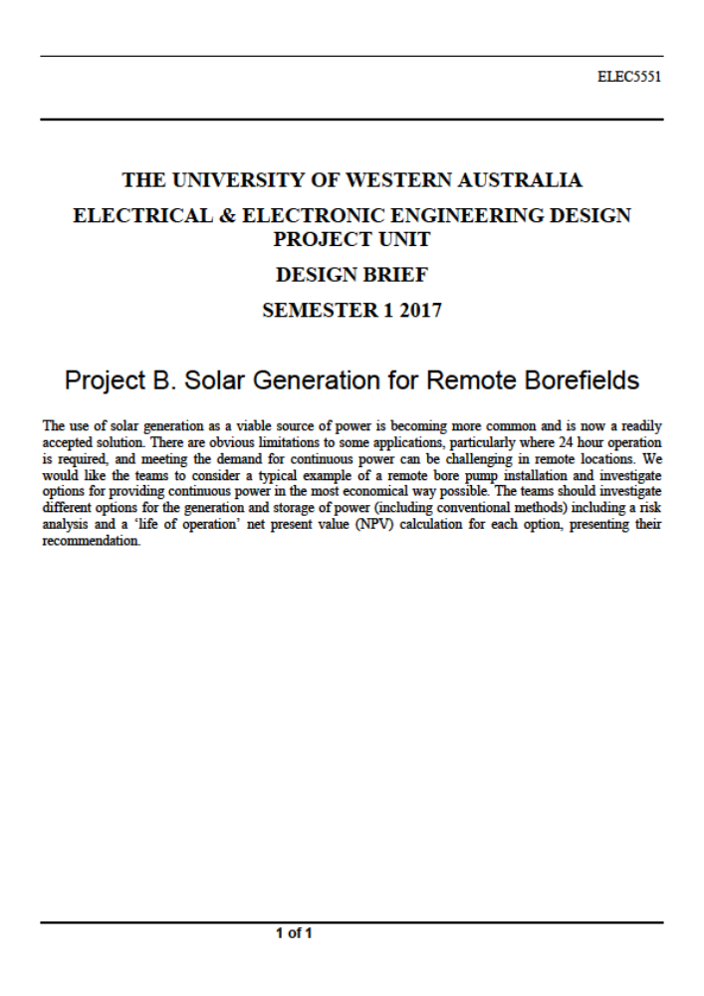

Appendix B: Climatic Information at Newman, WA
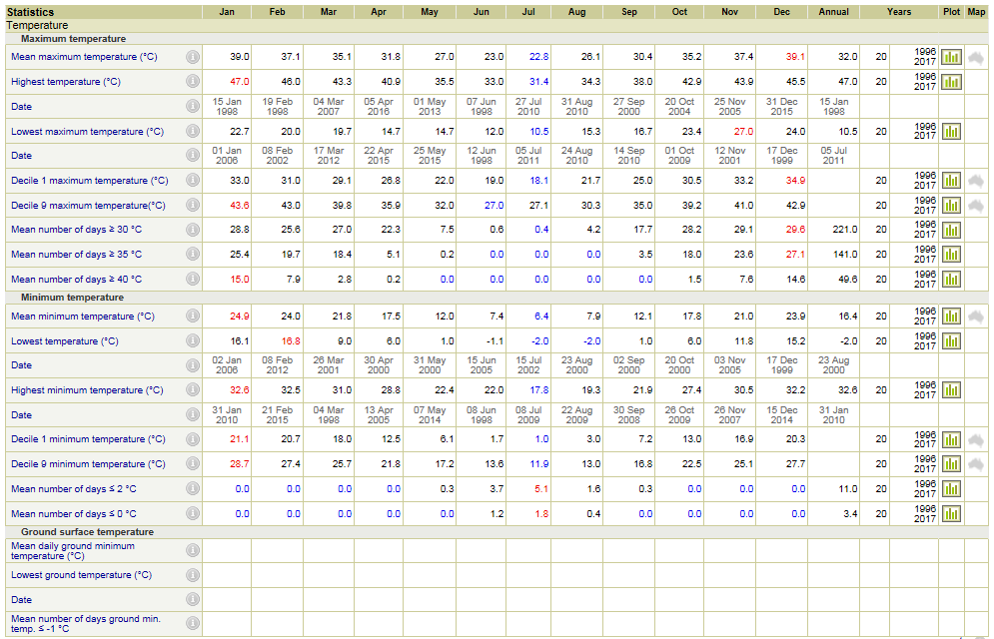
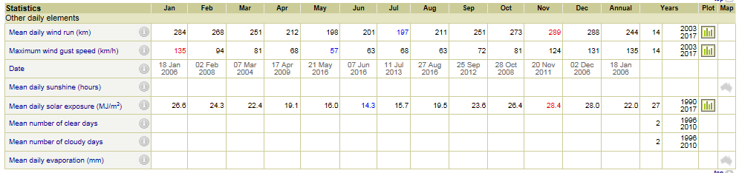

Appendix D: Requirements Priority Table including Classifications. EXP - Expecters, SPO - Spoken, UNS - Unspoken, EXC - Exciters
